**EMERGENCY CREDIT LINE GUARANTEE SCHEME (ECLGS)**



**ECLGS Manual**

|  |  |  |
| --- | --- | --- |
| **Sr. No.** | **Particulars** | **Page No.** |
| 1 | Login Page | 2 |
| 2 | MLI Registration, Creation for Branch ID | 3 |
| 3 | Lodgement Of ECLGS 1.0 and ECLGS 1.0 Extension | 5 |
| 4 | Lodgement Of ECLGS 2.0 and ECLGS 2.0 Extension | 8 |
| 5 | Lodgement Of ECLGS 3.0 and ECLGS 3.0 Extension | 11 |
| 6 | Bulk Upload ECLGS 1.0, ECLGS 1.0 Extension, ECLGS 2.0, ECLGS 2.0 Extension, ECLGS 3.0, ECLGS 3.0 Extension and Mudra | 13 |
| 7 | Lodgement Of ECLGS 4.0 | 15 |
| 8 | Additional/Incremental Guarantee | 17 |
| 9 | Additional/Incremental Bulk Upload | 18 |
| 10 | Partial Disbursement | 19 |
| 11 | Modifications in Partial Disbursement | 21 |
| 11 | ECLGS 1.0 Restructure Cases | 22 |
| 12 | Issue Additional Guarantee of 10% for Restructure Cases | 24 |
| 13 | NPA Marking | 26 |
| 14 | NPA Bulk Upload | 27 |
| 15 | NPA Standardization | 29 |
| 16 | Interim Claim | 31 |
| 17 | Final Claim | 36 |
| 18 | Bureau Bulk Upload | 40 |
| 19 | Closure Entry | 41 |
| 20 | Update Mudra ITPAN Bulk Upload | 42 |

Login to the ECLGS application. WEBSITE www.eclgs.com

**USER MANUAL for Lodgement of ECLGS 1.0, 1.0 Extension, ECLGS 2.0, 2.0 Extension, ECLGS 3.0, 3.0 Extension, ECLGS 4.0**

**NPA Standardisation – MLI Checker level**

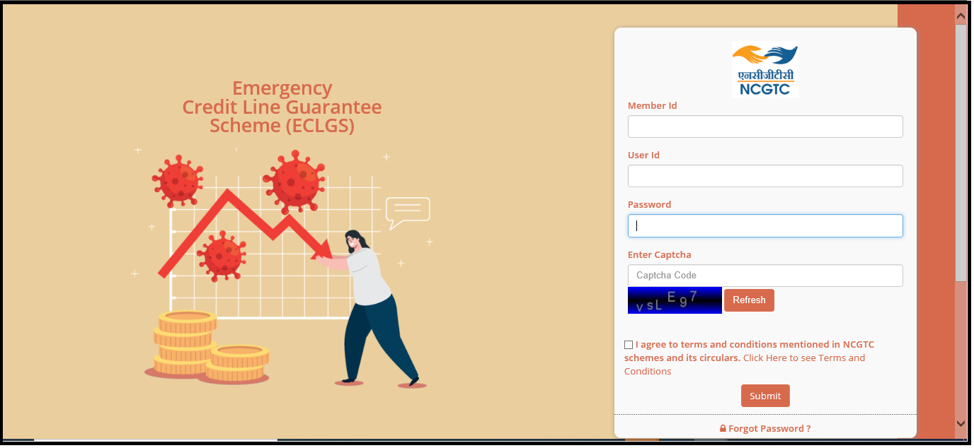

1. Enter Member ID

2. Enter User ID

3. Enter Password

4. Enter Captcha

5. Agree Terms and Condition

6. Click on ‘**Submit**’ button

**Forgot Password**

1. Click Forgot Password

2. Enter Hint Answer

3. Click on Save

**MLI Registration**

**Menu :SysAdmin Audit 🡪 MLI 🡪 Register MLI**

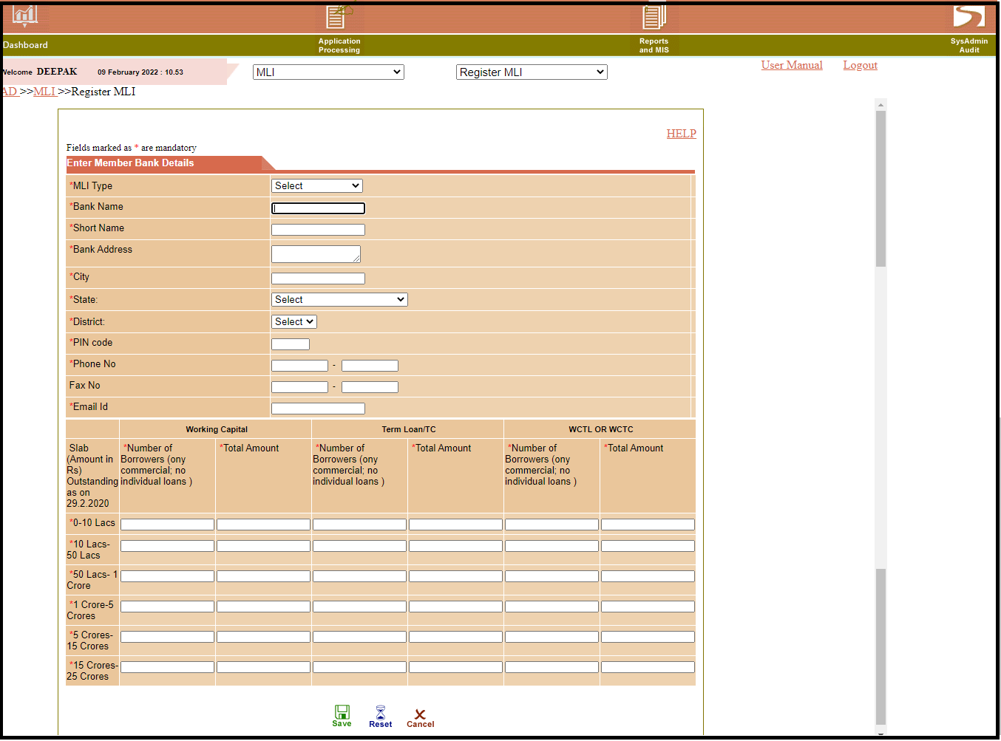

1. Select MLI 🡪 Register MLI

2. Enter all the details which are provided by MLI

3. Click on **Save**

**4.** After Click on **Save,** Enter HO user details and click on **Save**

**Only NCGTC user ID to create Checker ID**

**Only MLI Checker ID to Create Branch ID**

**Menu: Go to SysAdminAudit** 🡪 **MLI** 🡪 **Define Org. Structure**

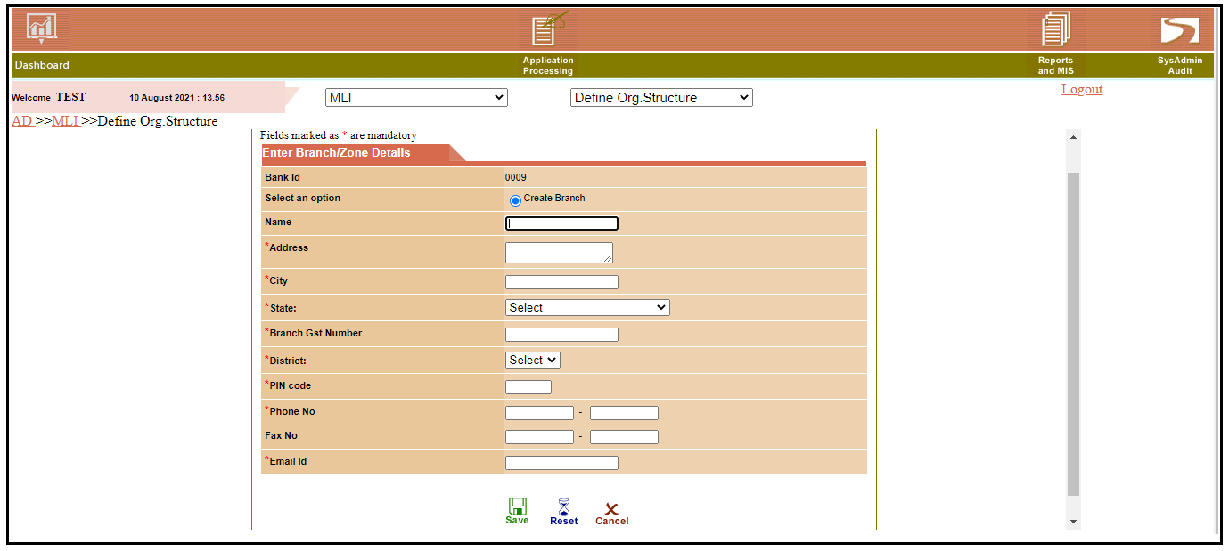

1. Click on SysAdminAudit

2. Go to MLI 🡪Define Org. Structure

3. Enter all the details

4. Click on save

5. Mail will send to the register email ID for maker creation details.

**Note: For ECLGS 1.0, Only Bulk Upload is available**

**Lodgement of ECLGS 1.0 (Launch Date – 23 May 2020)**

1. Date of Emergency Facility Sanctioned should be after 23rd May 2020 for ECLGS 1.0
2. Amount of Emergency Facility Sanctioned up to 20% of loan outstanding as on 29/02/2020 for ECLGS 1.0
3. Principal Amount Repayment Moratorium Period should be 12 months for ECLGS 1.0
4. Tenure of Emergency Funding Facility should be 48 months for ECLGS 1.0

**ECLGS 1.0 Extension (Launch Date – 01 Oct 2021)**

**Menu: Go to Application processing** 🡪 **Application Lodgement** 🡪 **Non-Mudra Entry Application processing** 🡪 **Application Lodgement** 🡪**Mudra Entry**

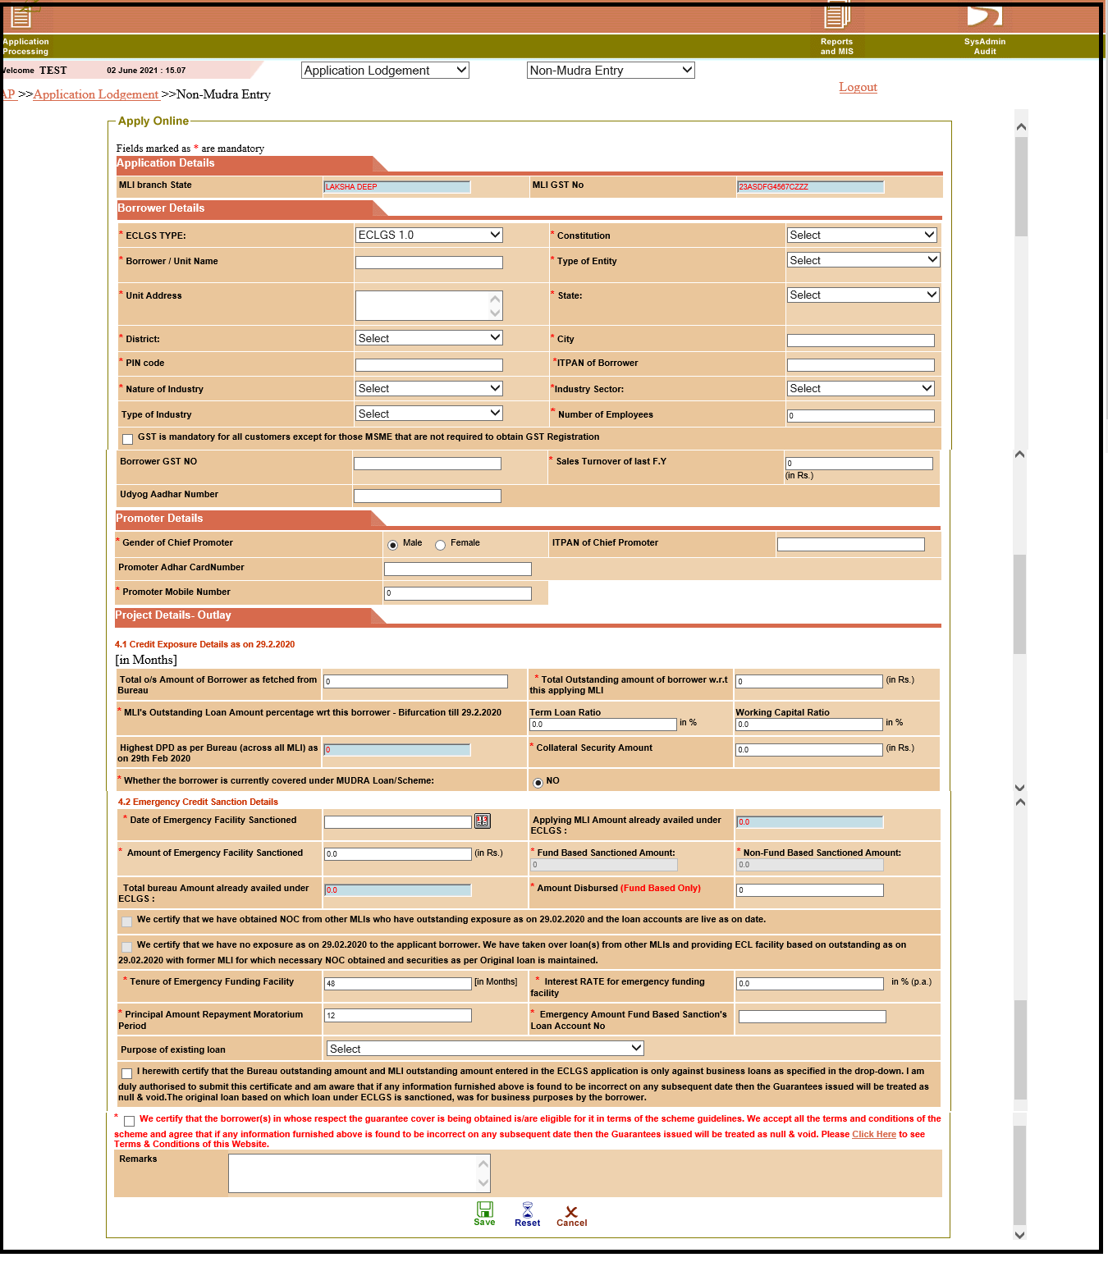

1. Select Mudra/Non Mudra

2. Select ECLGS Type as **ECLGS 1.0 Extension**

3. Enter **ITPAN of Borrower** base on selection of **Constitution** - first 5 digits as alphabetic and in 4th digit in case of "Individuals or Proprietor as 'P', Artificial Juridical Person as 'J', Partnership firms/LLP as 'F', Private/Public ltd as 'C', HUF as 'H', Trust type as 'T' and Society/co-operative society as 'A' or 'B'" and next 4 digits are numbers(all ≠ '0') and last digit must be alphabet respectively.

4. Select **State**, based on state selection **District** will display in District dropdown.

5. Select **Nature of Industry,** based on Nature of Industry selection **Industry Sectors** will display in dropdown related to **ECLGS 1.0 Extension**

6. List of Nature of Industry –

1. MINNING AND QUARRYING (INCL. COAL)

2. FOOD PROCESSING

3. BEVRAGE AND TOBACCO

4. TEXTILE

5. LEATHER AND LEATHER PRODUCTS

6. WOOD AND WOOD PRODUCTS

7. PAPER AND PAPER PRODUCTS

8. PETROLEUM, COAL PRODUCTS AND NUCLEAR FUELS

9. CHEMICAL AND CHEMICAL PRODUCTS

10. RUBBER, PLASTIC AND THEIR PRODUCTS

11. GLASS AND GLASS WARE

12. CEMENT AND CEMENT PRODUCT

13. BASIC METAL AND METAL PRODUCT

14. ALL ENGINEERING

15. VEHICLES, VEHICLES PART AND TRANSPORT EQUIPMENTS

16. GEMS ANG JEWELLERY

17. CONSTRUCTION

18. INFRASTRUCTURE

19. OTHER INDUSTRY

20. SERVICES

21. TRADERS

7. Enter **Total o/s Amount of Borrower as fetched from Bureau** up to Rs.50 crore

8. Enter **Total Outstanding amount of borrower w.r.t this applying MLI** up to Rs.50 crore

9.Enter **Highest DPD as per Bureau (across all MLI) as on 29th Feb 2020/31st March 2021** up to 60 days

10. Enter **Date of Emergency Facility Sanctioned** should be after is 1st October 2021 for ECLGS 1.0 Extension

11**.** Enter **Amount of Emergency Facility Sanctioned** up to 30% of loan outstanding as on 29/02/2020 or 31/03/2021 (Whichever is higher) for ECLGS 1.0 Extension

12**.** Enter **Interest RATE for emergency funding facility** for Bank Maximum cap is 9.25% and for NBFCs 14%

13. **Tenure of Emergency Funding Facility**should be **60 months for** **ECLGS 1.0 Extension.**

14. **Principal Amount Repayment Moratorium Period** should be **24 months for** **ECLGS 1.0 Extension.**

15**.** Enter all mandatory fields and click on **‘Save’**

16. Reference ID will generate

17. Go to **Reports and MIS** menu, select **Application Status,** and enterReference ID click on **‘OK’**

18. **CGPAN** will be displayed

**Note: For ECLGS 2.0, Only Bulk Upload is available**

**Lodgement of ECLGS 2.0 (Launch Date – 01 December 2020)**

**ECLGS 2.0 Extension (Launch Date – 01 October 2021)**

1. Date of Emergency Facility Sanctioned should be after 23rd May 2020 for ECLGS 2.0
2. Amount of Emergency Facility Sanctioned up to 20% of loan outstanding as on 29/02/2020 for ECLGS 2.0
3. Principal Amount Repayment Moratorium Period should be 24 months for ECLGS 2.0
4. Tenure of Emergency Funding Facility should be 60 months for ECLGS 2.0
5. Constitution ‘**Individual (Non Mudra)**’ is not applicable in **ECLGS 2.0,**
6. In **ECLGS 2.0** user have to enter **Fund Base sanction Amount** and **Non Fund Base sanction Amount**

**ECLGS 2.0 Extension (Launch Date – 01 October 2021)**

**Menu: Go to Application Processing** 🡪**Application Lodgement** 🡪 **Non-Mudra Entry**

1. Select ECLGS Type as **ECLGS 2.0 Extension.**

2. Constitution ‘**Individual (Non Mudra)**’ is not applicable in **ECLGS 2.0 Extension.**

3. Enter **ITPAN of Borrower** base on selection of **Constitution** - first 5 digits as alphabetic and in 4th digit in case of Artificial Juridical Person as 'J', Partnership firms/LLP as 'F', Private/Public ltd as 'C', HUF as 'H', Trust type as 'T' and Society/co-operative society as 'A' or 'B'" and next 4 digits are numbers (all ≠ '0') and last digit must be alphabet respectively.

4. Select **State**, based on state selection **District** will display in District dropdown.

5. Select **Nature of Industry,** based on Nature of Industry selection **Industry Sectors** will display in dropdown related to **ECLGS 2.0 Extension.**

6. List of Nature of Industry –

1. POWER

2. CONSTRUCTION

3. IRON & STEEL MANUFACTURING

4. ROADS

5. REAL ESTATE

6. TRADING – WHOLESALE

7. TEXTILES

8. CHEMICALS

9. CONSUMER DURABLE /FMCG

10. NON FERROUS METALS

11. PHARMACEUTOCALS MANUFACTURING

12. LOGISTICS

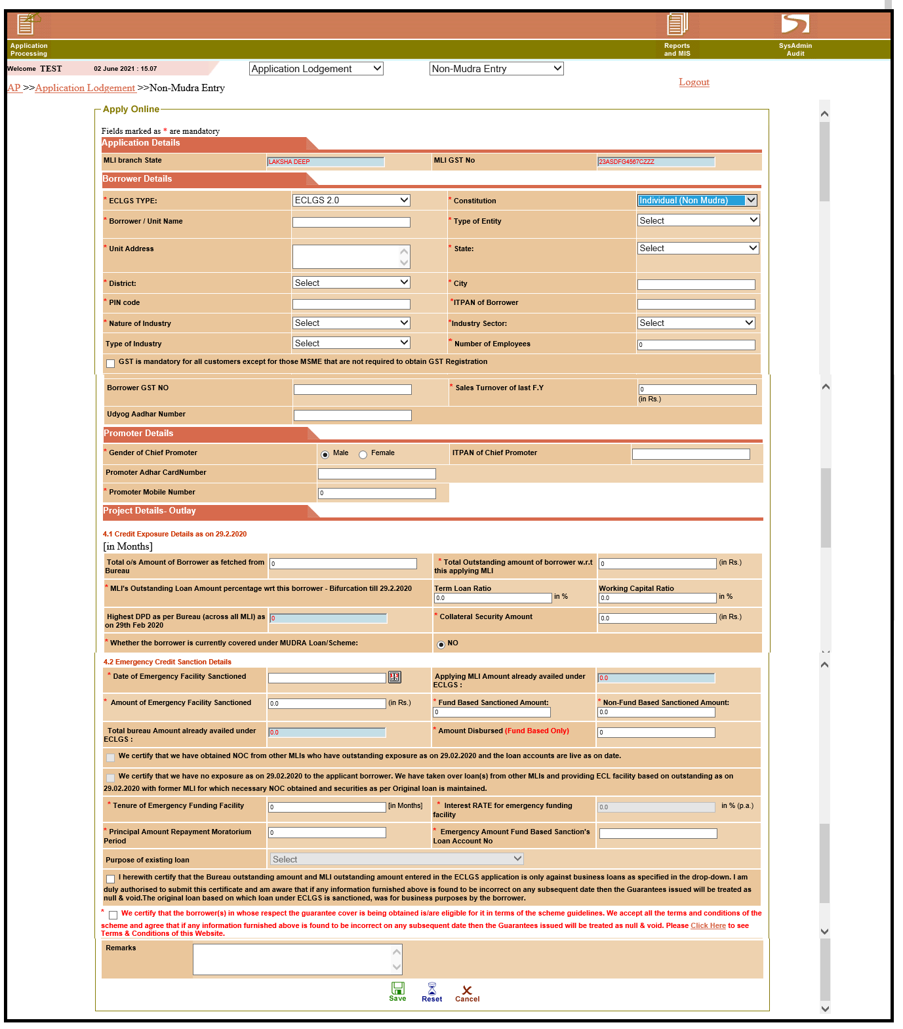

13. GEMS & JEWELLERY

14. CEMENT

15. AUTO COMPONENTS

16. HOTEL, RESTRURANTS, TOURISM

17. MINING

18. PLASTIC PRODUCT MANUFACTURING

19. AUTOMOBILE MANUFACTURING

20. AUTO DELEARSHIP

21. AVIATION

22. SUGAR

23. PORT AND PORT SERVICES

24. SHIPPING

25. BUILDING MATERIAL

26. CORPORATE RETAIL OUTLETS

27. HEALTH CARE

7. Enter **Total o/s Amount of Borrower as fetched from Bureau** above Rs.50 crore

And not exceeding Rs.500 crore.

8. Enter **Total Outstanding amount of borrower w.r.t this applying MLI** above Rs.50 crore And not exceeding Rs.500 crore.

9. **Highest DPD as per Bureau (across all MLI) as on 29th Feb 2020/31st March 2021 -** (Previously 30 days)nowup to 60 days effect from 01 April 2021.

10. Enter **Date of Emergency Facility Sanctioned** should be 1st October 2021 for ECLGS 2.0 Extension.

11**.** Enter **Amount of Emergency Facility Sanctioned** up to 30% of loan outstanding as on 29/02/2020 or 31/03/2021 (Whichever is higher) for ECLGS 2.0 Extension

12**.** Enter **Interest RATE for emergency funding facility** for Bank maximum cap is 9.25% and for NBFCs 14%

13. In ECLGS 2.0 Extension user can enter **Fund Base sanction Amount** and **Non Fund Base sanction Amount**

14. **Purpose of Existing Loan** will be disabled.

15. **Tenure of Emergency Funding Facility**should be **72 month for ECLGS 2.0 Extension.**

16. **Principal Amount Repayment Moratorium Period** should be **24 months for ECLGS 2.0 Extension.**

17**.** Enter all mandatory fields and click on **‘Save’**

18. Reference ID will generate

19. Go to **Reports and MIS** menu, select **Application Status,** and enterReference ID click on **‘OK’**

20**. CGPAN** will displayed.

**Note: For ECLGS 3.0 Only Bulk Upload is available**

**Lodgement of ECLGS 3.0 (Launch Date – 1st April 2021)**

1. Constitution ‘**Individual (Non Mudra)**’ is only applicable for Purpose of loan Own Business Purposes utilised out of Loan Against Property in **ECLGS 3.0**
2. Date of Emergency Facility Sanctioned should be after 01April 2021 for ECLGS 3.0
3. Amount of Emergency Facility Sanctioned up to 40% of loan outstanding as on 29/02/2020 for ECLGS 2.0
4. Principal Amount Repayment Moratorium Period should be 24 months for ECLGS 3.0
5. Tenure of Emergency Funding Facility should be 72 months for ECLGS 3.0

**ECLGS 3.0 Extension (Launch Date – 1st October 2021)**

**Menu: Go to Application Processing** 🡪**Application Lodgement** 🡪 **Non- Mudra Entry**

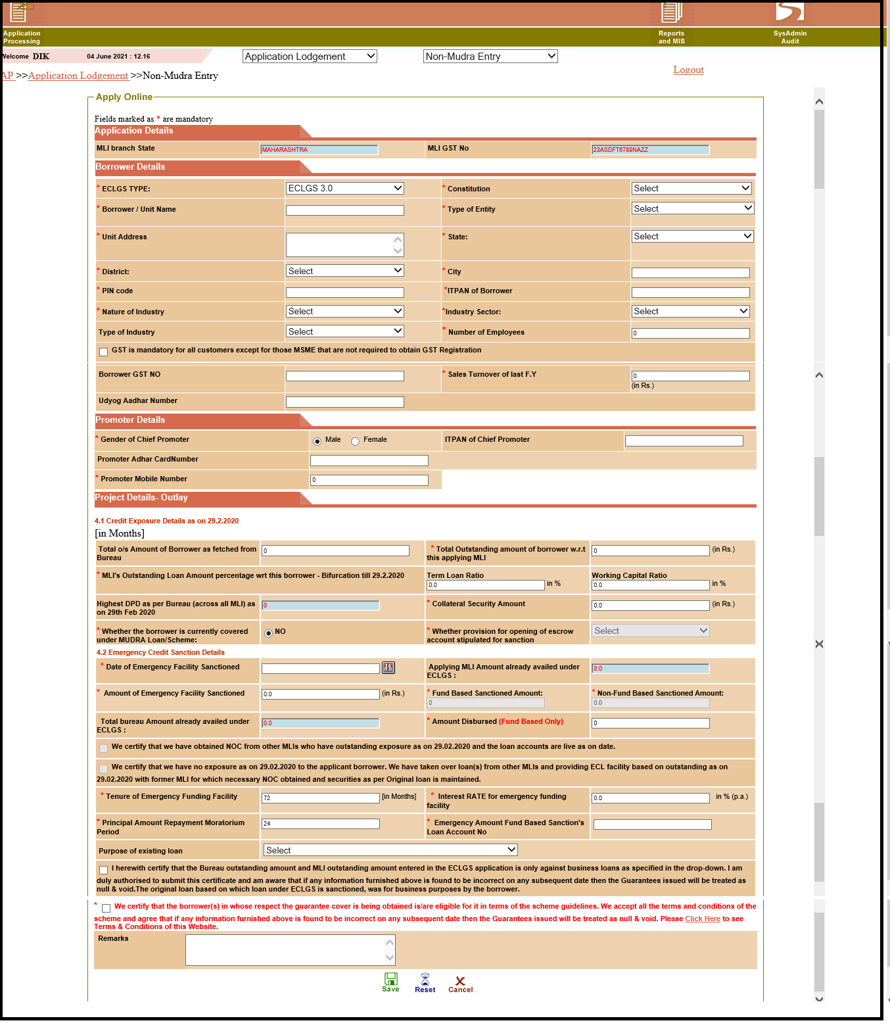

1. Select ECLGS Type as **ECLGS 3.0 Extension.**

2. Constitution ‘**Individual (Non Mudra)**’ is only applicable for Purpose of loan Own Business Purposes utilised out of Loan Against Property in **ECLGS 3.0 Extension.**

3. Enter **ITPAN of Borrower** base on selection of **Constitution** - first 5 digits as alphabetic and in 4th digit in case of "Individuals or Proprietor as 'P', Artificial Juridical Person as 'J', Partnership firms/LLP as 'F', Private/Public ltd as 'C', HUF as 'H', Trust type as 'T' and Society/co-operative society as 'A' or 'B'" and next 4 digits are numbers(all ≠ '0') and last digit must be alphabet respectively.

4. Select **State**, based on state selection **District** will display in District dropdown.

5. Select **Nature of Industry,** based on Nature of Industry selection **Industry Sectors** will display in dropdown related to **ECLGS 3.0 Extension.**

6. List of Nature of Industry –

1. HOSPITALITY

2. TRAVELS & TOURISM

3. SPORTS & LEISURE

4. CIVIL AVIATION (with effect from 01/06/2021)

7. Enter **Total o/s Amount of Borrower as fetched from Bureau** above Rs.50 crore and up to Rs.500 crore. This has been discontinued with effect from 01/06/2021.

8. Enter **Total Outstanding amount of borrower w.r.t this applying MLI** above Rs.50 crore and up to Rs.500 crore. This has been discontinued with effect from 01/06/2021.

9.Enter **Highest DPD as per Bureau (across all MLI) as on 29th Feb 2020/31st March 2021** up to 60 days

10. Enter **Date of Emergency Facility Sanctioned** should be after 1st October 2021 for ECLGS 3.0 Extension

11**.** Enter **Amount of Emergency Facility Sanctioned** up to 40% of loan outstanding as on 29/02/2020 or 31/03/2021(Whichever is higher). The same has been changed to **Amount of Emergency Facility Sanctioned** up to 40% of loan outstanding or max Rs.200 crore with effect from 01/06/2021.

12**.** Enter **Interest RATE for emergency funding facility** for Bank maximum cap is 9.25% and for NBFCs 14%

13. **Purpose of Existing Loan** is only **Own Business Purposes Utilised out of Loan against Property** allowfor constitution ‘**Individual (Non Mudra)**’

14. **Tenure of Emergency Funding Facility**should be **72** months for ECLGS 3.0 Extension.

15. **Principal Amount Repayment Moratorium Period** should be **24 months for ECLGS 3.0 Extension.**

16**.** Enter all mandatory fields and click on **‘Save’**

17. Reference ID will generate.

18. Go to **Reports and MIS** menu, select **Application Status,** and enterReference ID click on **‘OK’**

19**. CGPAN** will displayed.

**Borrowers who have avail under ECLGS 1.0 or ECLGS 2.0 are permitted to avail additional 20% only under ECLGS 3.0**

Bulk Upload ECLGS 1.0 , ECLGS 1.0 Extension, ECLGS 2.0, ECLGS 2.0 Extension, ECLGS 3.0, ECLGS 3.0 Extension and Mudra

**Menu**: **Go to** **Application processing** 🡪  **Application Lodgement** 🡪 **Non – Mudra Bulk Upload**

**Application processing** 🡪  **Application Lodgement** 🡪 **Mudra Bulk Upload**

**Application processing** 🡪 **Reports & MIS** 🡪 **Bulk File Download**

1. For Bulk Upload Mudra and Non Mudra Templates are provided on [www.ECLGS.com](http://www.ECLGS.com) Home Page “**Undertaking**“ folder.

2. Enter details as per provided format

3. Go to Application Lodgement Mudra Bulk File Upload/ Non Mudra Bulk File Upload

4. If any error is appears while bulk upload, check validations/Instructions are provided in template and resolve your errors and upload again.

5. Go to Reports and MIS

6. Select Bulk File Download

**Non- Mudra Bulk Upload**

**Application processing** 🡪  **Application Lodgement** 🡪 **Non – Mudra Bulk Upload**

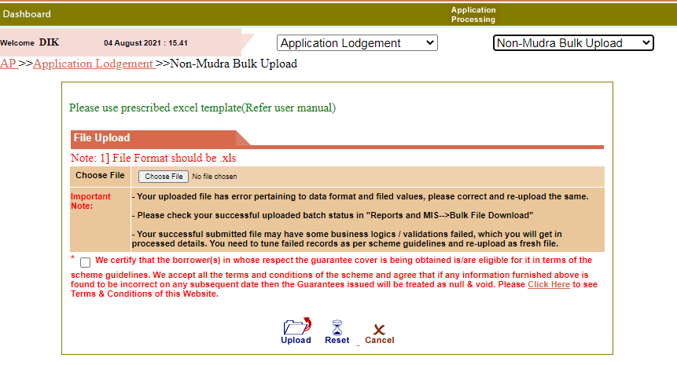

**Mudra Bulk Upload**

**Application processing** 🡪  **Application Lodgement** 🡪 **Mudra Bulk Upload**

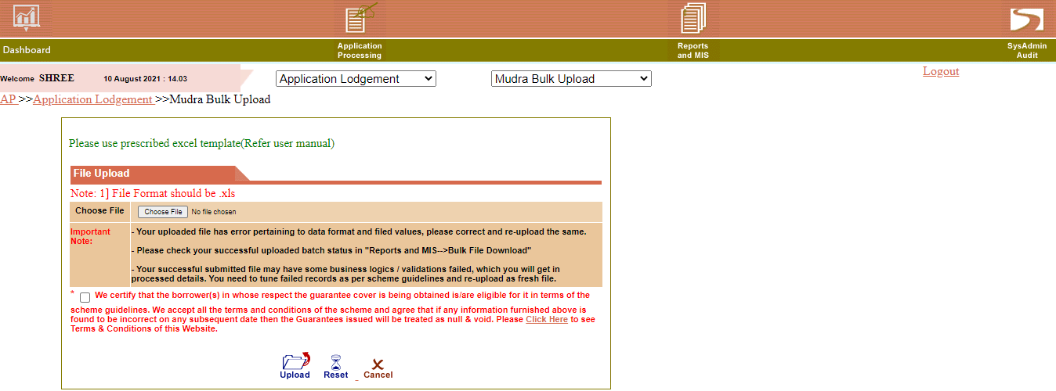

**Bulk File Download**

**Application processing** 🡪 **Reports & MIS** 🡪 **Bulk File Download**

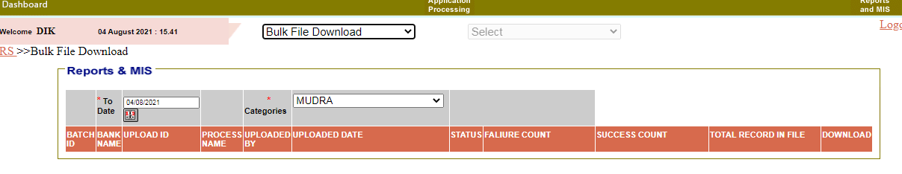

1. Go to Bulk File Download

2. Select Date and categories

3. Click on Download to download the file

**Lodgement of ECLGS 4.0 (Launch Date – 01 June 2021)**

**Note: Bulk Upload under ECLGS 4.0 not permitted.**

**Menu: Go to Application Processing** 🡪**Application Lodgement** 🡪 **Non- Mudra Entry**

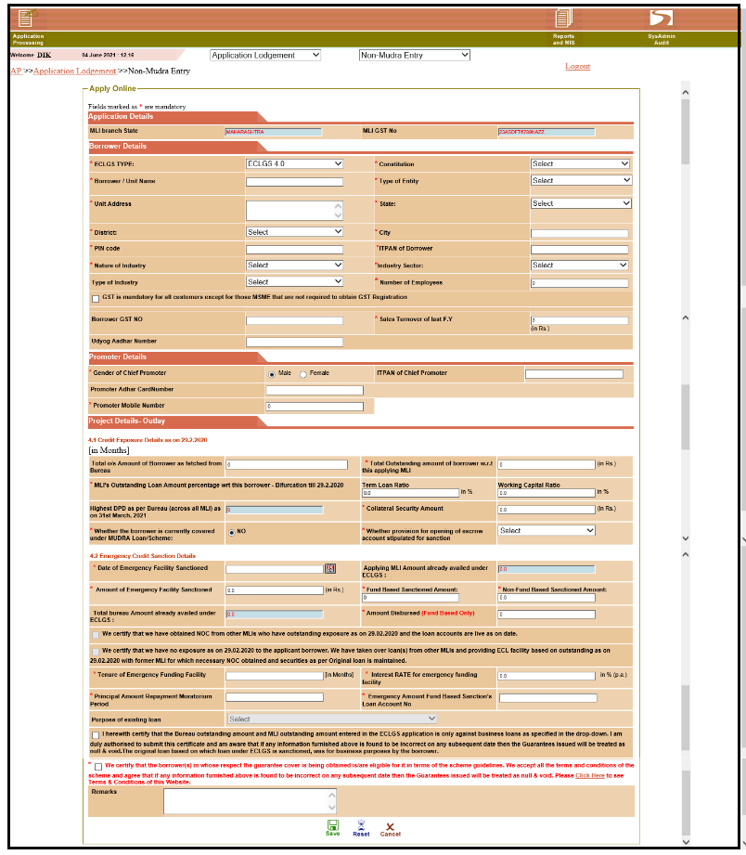

1. Select ECLGS Type as **ECLGS 4.0.**

2. Constitution ‘**Individual (Non Mudra)**’ is not applicable in **ECLGS 4.0**

3. Enter **ITPAN of Borrower** base on selection of **Constitution** - first 5 digits as alphabetic and in 4th digit in case of Artificial Juridical Person as 'J', Partnership firms/LLP as 'F', Private/Public ltd as 'C', HUF as 'H', Trust type as 'T' and Society/co-operative society as 'A' or 'B'" and next 4 digits are numbers (all ≠ '0') and last digit must be alphabet respectively.

4. Select **State**, based on state selection **District** will display in District dropdown.

5. Select **Nature of Industry,** based on Nature of Industry selection **Industry Sectors** will display in dropdown related to **ECLGS 4.0.**

6. List of Nature of Industry –

1. OXYGEN GENERATION PLANTS

7. Industry Sectors –

1. Private / public Hospitals

2. Nursing Home / Clinics

3. Private / Public Medical College

4. Liquid Oxygen Manufacturing Units

5. Oxygen Cylinder Manufacturing Units

8. Enter **Total o/s Amount of Borrower as fetched from Bureau**

9. Enter **Total Outstanding amount of borrower w.r.t this applying MLI**

10.Enter **Highest DPD as per Bureau (across all MLI) as on 31st March 2021** up to 90 days

11. Enter **Date of Emergency Facility Sanctioned** should be after31st May 2021

12**.** Enter **Amount of Emergency Facility Sanctioned** up to Rs.2 crore.

13. In **ECLGS 4.0** user can enter **Fund Base sanction Amount** and **Non Fund Base sanction Amount**

14**.** Enter **Interest RATE for emergency funding facility** for Bank and NBFCs maximum cap is 7.5%

15. **Purpose of Existing Loan** will be disable.

16.Enter **Tenure of Emergency Funding Facility**should be **more than 6 and up to 60 months**

17. Enter **Principal Amount Repayment Moratorium Period** should be **6 months**

18. Enter **Name of Existing Lender.**

19. Select **‘Yes’** from **whether provision for opening of escrow account stipulated for sanction** field.

20**.** Enter all mandatory fields and click on **‘Save’**

21. Reference ID will generate.

22. Go to **Reports and MIS** menu, select **Application Status,** and enterReference ID click on

23. CGPAN will be displayed

**Note : Additional/Incremental Bulk Upload is available for ECLGS 1.0, ECLGS 1.0 Extension, ECLGS 2.0, ECLGS 2.0 Extension, ECLGS 3.0 CGPANs are only allow for Bureau O/S as on 31/03/2021. ECLGS 4.0 CGPANs are not allow.**

**Additional/Incremental Guarantee (Launch Date – 1 October 2021)**

**Menu : Go to Application Processing 🡪Application Lodgement🡪Additional**

**/Incremental Guarantee**

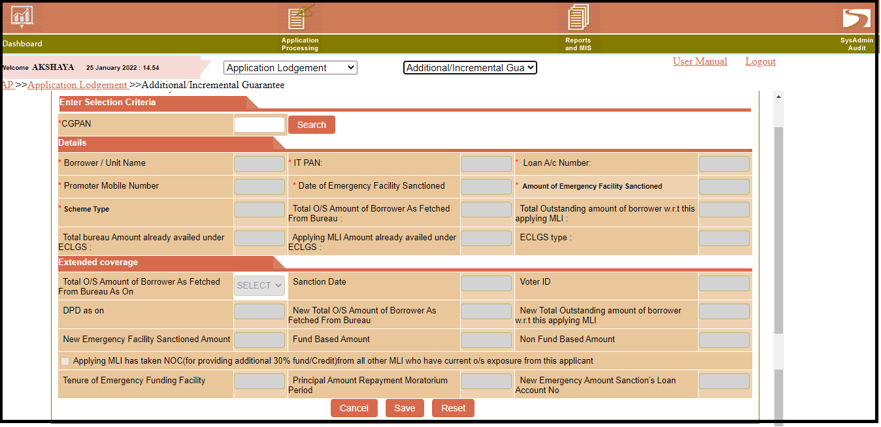

1. Enter **CGPAN** and click on **Search** button

2. Select option 29/02/2020 or 31/03/2021 **Total O/S Amount of Borrower As Fetch from Bureau As On**.

3. Select **Sanction Date**

4. Select **Voter ID** (Mandatory for Mudra CGPAN)

5.Enter **Total O/S Amount of Borrower As Fetch from Bureau** for mudra cases -

O/S amount up to 50000 in case of Shishu for Bureau O/S as on 29/02/2020

O/S amount above 50000 up to 5 lakhs in case of Kishor for Bureau O/S as on 29/02/2020

O/S amount above 5 lakh up to 10 Lakhs in case of Tarun for Bureau O/S as on 29/02/2020

O/S amount up to 5 lakh in case of Shishu for Bureau O/S as on 31/03/2021

O/S amount above 5 Lakh up to 10 lakhs in case of Kishor for Bureau O/S as on 31/03/2021

O/S amount above 10 Lakh up to 13 lakh in case of Tarun for Bureau O/S as on 31/03/2021

Enter **Total O/S Amount of Borrower As Fetch from Bureau** for Non mudra cases

ECLGS 1.0 and ECLGS 1.0 Extension up to 50Cr Bureau O/S as on 29/02/2020 or 31/03/2021

ECLGS 2.0 and ECLGS 2.0 Extension up to 500Cr Bureau O/S as on 29/02/2020 or 31/03/2021

6. Enter **New Outstanding Amount of Borrower w.r.t. MLI**

7. Enter **New Emergency facility Sanction Amount** up to 30% of MLI/BUREAU O/S for ECLGS 1.0, ECLGS 1.0 Extension, ECLGS 2.0, ECLGS 2.0 Extension and Mudra cases.

And for ECLGS 3.0 and ECLGS 3.0 Extension up to 40% of MLI/BUREAU O/S or Maximum 200 Cr.

8. Enter **Fund Base Amount** (If CGPAN is of ECLGS 2.0 or ECLGS 2.0 Extension)

9. Enter **Non Fund Base Amount** ((If CGPAN is of ECLGS 2.0 or ECLGS 2.0 Extension))

10.**Tenure of Emergency Funding Facility** is auto fetch based on CGPAN Scheme Type

12.**Principal Amount of Repayment Moratorium Period** is auto fetch based on CGPAN Scheme Type

13.Enter **New Emergency Amount sanction Loan Account No**

**Additional/Incremental Bulk Upload**

**Menu : Application Processing 🡪 Application Lodgement🡪 Additional/Incremental Bulk Upload**

**Application processing** 🡪 **Reports & MIS** 🡪 **Bulk File Download**

1. For Bulk Upload Additional/Incremental Bulk Upload Templates are provided on [www.ECLGS.com](http://www.ECLGS.com) Home Page “**Undertaking**“ folder.

2. Enter details as per provided format

3. Go to Application Lodgement🡪Additional Incremental Bulk upload

4. If any error is appears while bulk upload, check validations/Instructions are provided in template and resolve your errors and upload again.

5. Go to Reports and MIS

6. Select Bulk File Download

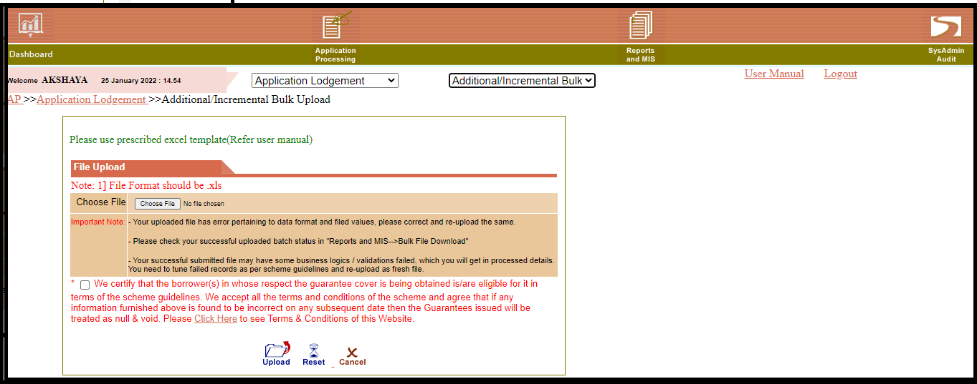

**Bulk File Download**

**Application processing** 🡪 **Reports & MIS** 🡪 **Bulk File Download**

1. Go to Bulk File Download

2. Select Date and categories

3. Click on Download to download the file

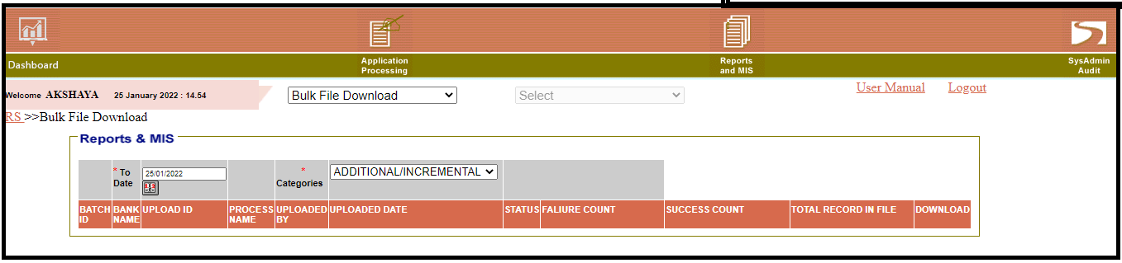

**Partial Disbursement**

**Note**: **Disbursement Bulk Upload for ECLGS 1.0, ECLGS 2.0, ECLGS 3.0, ECLGS 4.0 Fund Base is available**

**For Non- Fund Based Bulk Upload, ECLGS 1.0 Extension, ECLGS 2.0 Extension and ECLGS 3.0 Extension is not available.**

**Menu**: **Application Processing 🡪 Partial Disbursement 🡪 Partial Disbursement/ Utilization of NFB**

Fund Based –

1. Enter CGPAN of ECLGS 1.0 or ECLGS 2.0 or ECLGS 3.0 or ECLGS 4.0
2. Click on ‘**Search**’ icon
3. Select **Fund Based** from Fund Type.
4. Enter Fund Base Sanction Amount
5. Enter New Disbursement Amount
6. Enter Disbursement Date
7. Click on ‘**Save**’ icon

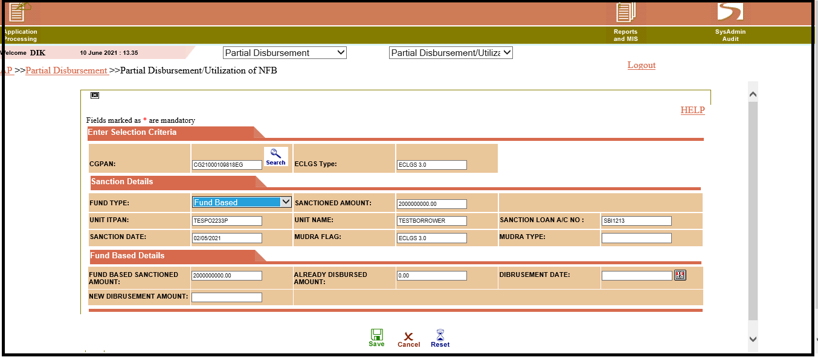

Non Fund Based –

1. Enter CGPAN of ECLGS 2.0 or ECLGS 4.0
2. Click on ‘**Search**’ icon
3. Select **Non** **Fund Based** from Fund Type.
4. Select Non Fund Base type From NFB Type dropdown
5. Enter Non Fund Base Sanction Amount
6. Enter BG/LC number
7. Enter Maturity/Guarantee Expiry Date
8. Enter Issue Amount
9. Enter Issue Date
10. Click on ‘**Save**’ icon

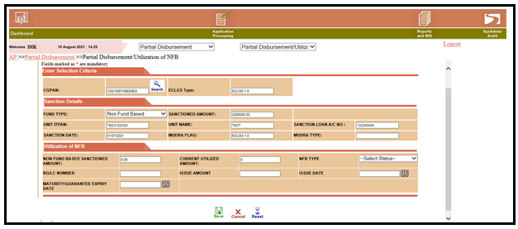

**Modifications in Partial Disbursement**

**Menu : Go to Application Processing**🡪**Partial Disbursement🡪Modifications in Partial Disbursement**

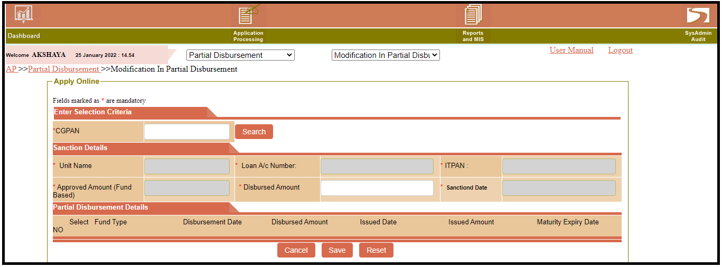

1. **Disbursement must be done for the CGPAN**

2. Enter **CGPAN** and click on **Search** button

3. Partial Disbursement details are display

4. Select checkbox to modify disbursement record

5. Update **Disbursement Date**

6. Update **Disbursed Amount**

7. Click on **Save**

**Mark Restructured [ECLGS 1.0] - MLI Maker level**

**Menu: Go to Application Processing**🡪 **Go to Application Lodgement** 🡪**Mark Restructured [ECLGS 1.0]**

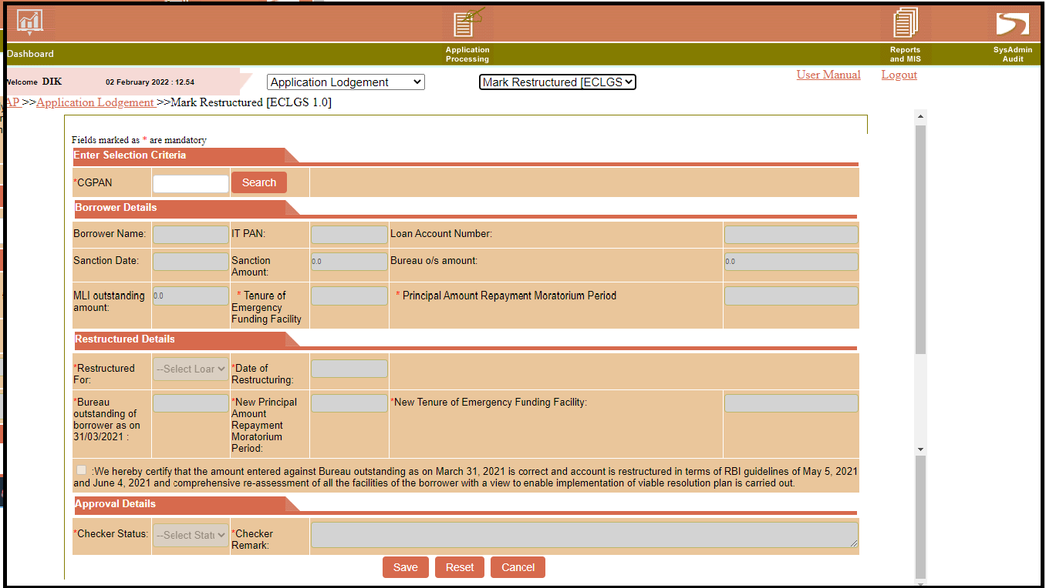

1. Go to Application Lodgement 🡪ECLGS 1.0 Restructure Cases
2. Enter CGPAN of **ECLGS 1.0**
3. Select ‘This GECL Loan against this <CGPAN> is restructure’ or ‘Parent Loan of this GECL <CGPAN> is restructure’ from **Restructure For** Drop-down.
4. Check “Restructuring as per RBI Resolution Plan dated May 05, 2021, and June 04, 2021” checkbox.
5. Display existing Moratorium Period and Tenure.
6. Enter **New Principle Amount Requirement Moratorium Period** between (13months - 24months)
7. Auto-calculate **New Tenure of Emergency Funding Facility** (Should be 36 + Moratorium period).
8. Select Date of Restructuring should be after May 5, 2021.
9. Enter ‘**Bureau outstanding of borrower as on 31/03/2021**’ (fund based & non-fund based) should be less than or equal to Rs. 50 Crore.
10. Select **Date of Restructuring.** Itshould be till **30 September 2021**
11. Click on **Save.**
12. Maker to forward the case to Checker

**Mark Restructured [ECLGS 1.0] - MLI Checker level**

**Menu: Application Processing**🡪 **Go to Application Lodgement** 🡪**Mark Restructured [ECLGS 1.0]**

1. Enter CGPAN of **ECLGS 1.0**
2. Select Checker Status.
3. Enter Checker Remark.
4. Click on **Save.**

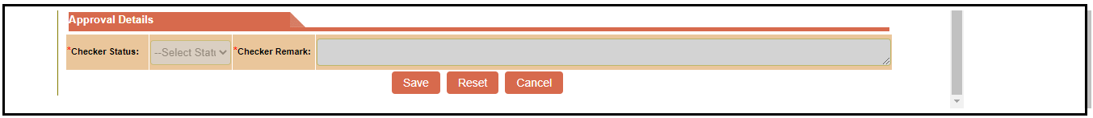

**Note :**

**1. NPA marked cases not allowed for restructuring.**

**2. Standard cases are allowed for restructuring**.

**3. This is applicable for both Mudra and Non-Mudra**.

**Issue Additional Guarantee of 10% for Restructured**

**Menu**: **Go to** **Application processing** 🡪  **Application Lodgement** 🡪 **Non – Mudra Bulk Upload**🡪**Select Type 🡪 ECLGS 1.0 Restructured**

**Application processing** 🡪  **Application Lodgement** 🡪  **Mudra Bulk Upload**🡪**Select Type 🡪 ECLGS 1.0 Restructured** 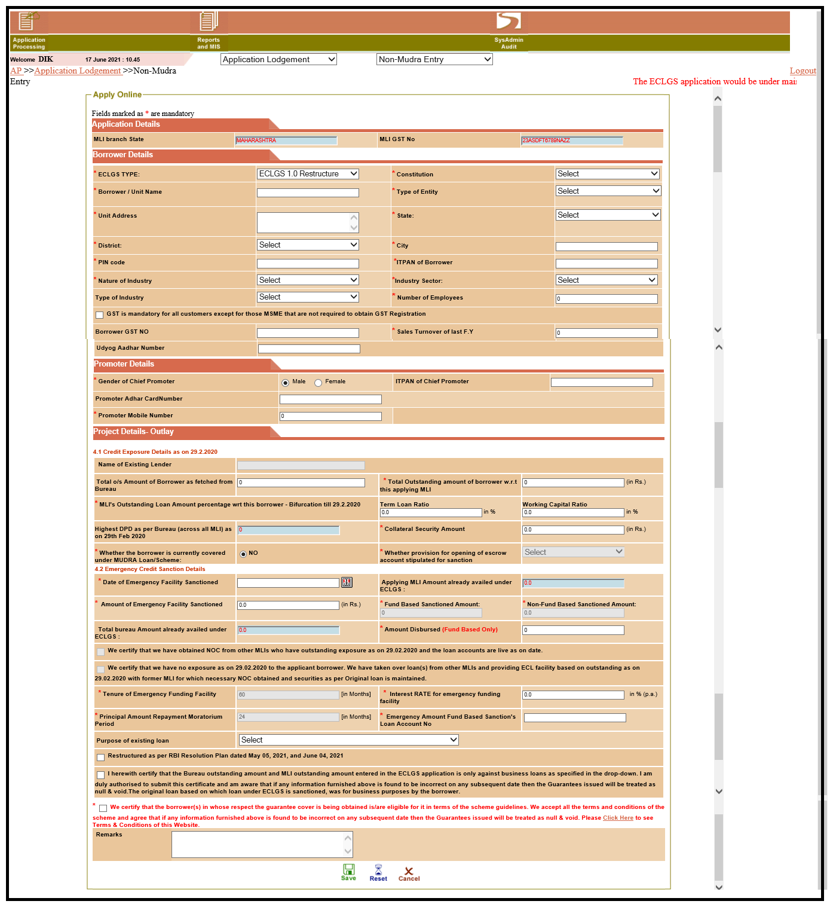

1. Go to Application Processing🡪Non Mudra Entry/ Mudra Entry
2. Select **ECLGS 1.0 Restructure** from **ECLGS Type** Dropdown
3. Provide mandatory checkbox as “Restructured as per RBI Resolution Plan dated May 05, 2021, and June 04, 2021”.
4. If borrower is having multiple CGPAN with a MLI then at least one CGPAN should be restructured to be eligible for additional 10% guarantee.
5. The additional 10 % Guarantee to be provided based on “Total Fund Based MLI Outstanding” as on Feb 29, 2020, only. However, the system should validate for the total guarantee cover is up to 30% of Bureau O/S amount as on Feb 29, 2020.
6. Only one CGPAN per ITPAN per MLI to be allowed for additional 10% guarantee under restructuring.
7. ‘Date of Emergency Facility Sanction’ should be after 31st May 2021.
8. By default, Tenure would be 60 months and Moratorium Repayment period would be 24 months.
9. Borrowers who have availed ECLGS 1.0 & ECLGS 3.0, would be eligible for Restructure but not for additional 10% guarantee cover.
10. Borrowers who availed additional 10% guarantee under ECLGS 1.0 restructure, then would not be eligible for assistance under ECLGS 3.0.
11. This is applicable for both Mudra and Non-Mudra.

**NPA Marking – MLI Maker level**

**Menu: Go to**  **Application Processing** 🡪 **Claim and Settlement** 🡪 **NPA marking**

1. Enter CGPAN

2. Click on ‘**Search**’ button

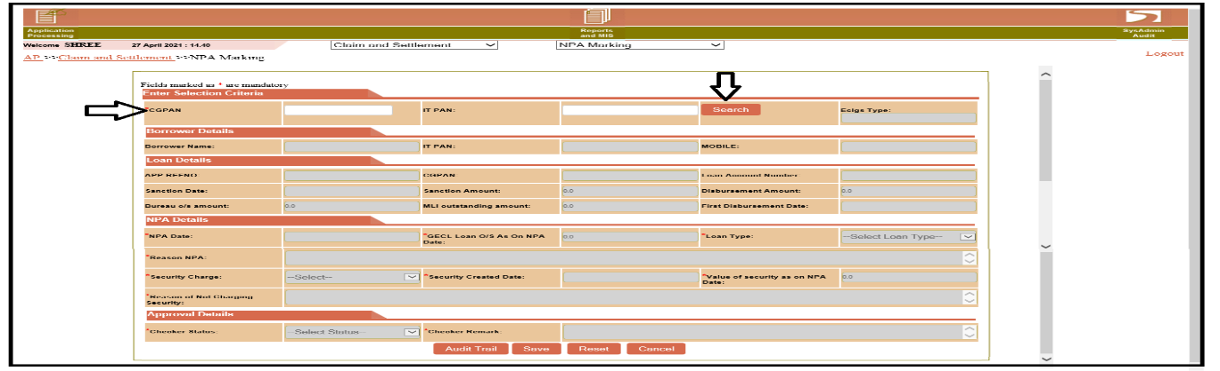

3. Enter Details

4. Click on ‘**Save**’ button – the data flows to MLI Checker level

**NPA Marking – MLI Checker level**

Login with ‘**MLI checker**’

6. Select ‘**Claim and Settlement**’ 🡪 ‘**NPA marking**’

7. Enter CGPAN and Click on ‘**Search’**

8. Enter Approval Details (If MLI Checker Return, then it will go back to MLI Maker)

9. Click on ‘**Save**’ - the data flows to NCGTC Maker level

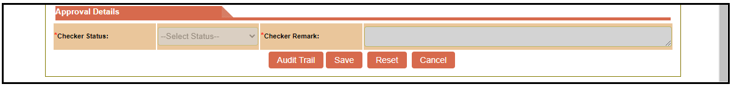

**NPA Bulk Upload**

|  |  |  |  |  |  |  |  |  |  |
| --- | --- | --- | --- | --- | --- | --- | --- | --- | --- |
| **1) Login with Maker id, Go to Application Processing-->Claim and Settlement-->NPA Bulk Upload** | | | | | | | | | |
| **While uploading data by Maker ID, Checker Status and Remark should be blank.** | | | | | | | |  |  |
|    |  | | --- | |  | |  |  |  |  |  |  |  |  |  |
|  |  |  |  |  |  |  |  |  |  |
|  |  |  |  |  |  |  |  |  |  |
|  |  |  |  |  |  |  |  |  |  |
|  |  |  |  |  |  |  |  |  |  |
|  |  |  |  |  |  |  |  |  |  |
|  |  |  |  |  |  |  |  |  |  |
|  |  |  |  |  |  |  |  |  |  |
|  |  |  |  |  |  |  |  |  |  |
|  |  |  |  |  |  |  |  |  |  |
|  |  |  |  |  |  |  |  |  |  |
|  |  |  |  |  |  |  |  |  |  |
| **2) For NPA Maker bulk file status, Go to Report and MIS-->Bulk File Download** | | | | | | | |  |  |
| **Select NPA maker Bulk File Status from 'Categories' dropdown.** | | | | | | |  |  |  |
|  |  |  |  |  |  |  |  |  |  |
| **3) Checker pending records follow path is Reports and MIS-->Bulk File Download,**  **to download NPA Maker** | | | | | | | | | |
|    |  | | --- | |  | |  |  |  |  |  |  |  |  |  |
|  |  |  |  |  |  |  |  |  |  |
|  |  |  |  |  |  |  |  |  |  |
|  |  |  |  |  |  |  |  |  |  |
|  |  |  |  |  |  |  |  |  |  |
|  |  |  |  |  |  |  |  |  |  |
|  |  |  |  |  |  |  |  |  |  |
|  |  |  |  |  |  |  |  |  |  |
|  |  |  |  |  |  |  |  |  |  |
|  |  |  |  |  |  |  |  |  |  |
|  |  |  |  |  |  |  |  |  |  |
|  |  |  |  |  |  |  |  |  |  |
| **4)Login with Checker ID, Go to Application Processing-->Claim and Settlement-->**  **NPA Bulk Upload** | | | | | | | | | |
|  |  |  |  |  |  |  |  |  |  |
|  |  |  |  |  |  |  |  |  |  |
|  |  |  |  |  |  |  |  |  |  |
|  |  |  |  |  |  |  |  |  |  |
|  |  |  |  |  |  |  |  |  |  |
|  |  |  |  |  |  |  |  |  |  |
|  |  |  |  |  |  |  |  |  |  |
| **5) Checker bulk file uploaded status path is Reports and MIS -->Bulk File Download** | | | | | | | | |  |
|    |  | | --- | |  | |  |  |  |  |  |  |  |  |  |
|  |  |  |  |  |  |  |  |  |  |
|  |  |  |  |  |  |  |  |  |  |
|  |  |  |  |  |  |  |  |  |  |
|  |  |  |  |  |  |  |  |  |  |
|  |  |  |  |  |  |  |  |  |  |
|  |  |  |  |  |  |  |  |  |  |
|  |  |  |  |  |  |  |  |  |  |
|  |  |  |  |  |  |  |  |  |  |

**NPA Standardization – MLI Maker level**

**Menu: Go to Application Processing🡪** **Claim and Settlement**🡪 **NPA Standardization**

1. Enter CGPAN

2. Click on ‘**Search**’ button

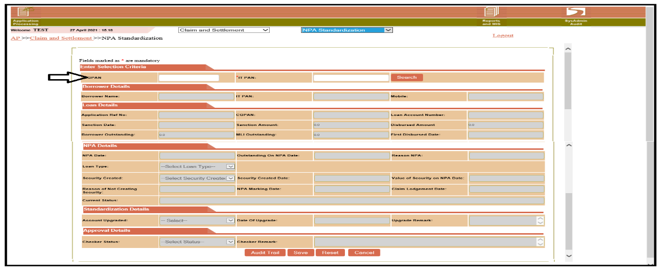

3. Enter details

4. Click on ‘**Save**’ button - the data flows to MLI Checker level

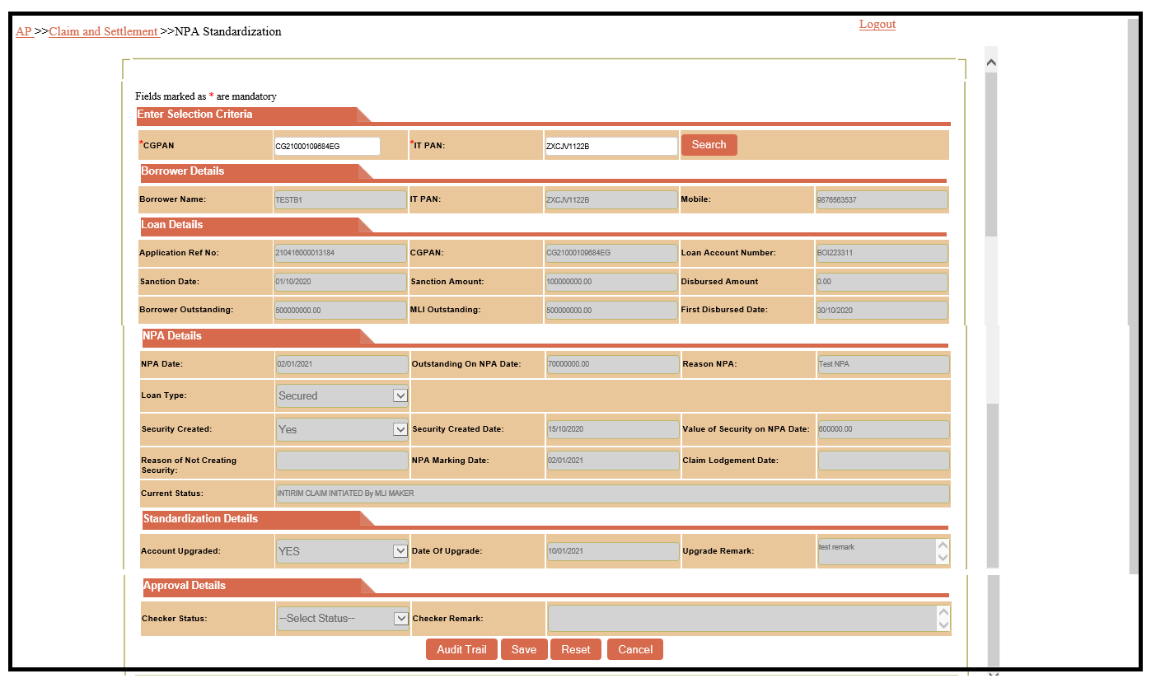

**NPA Standardisation – MLI Checker level**

**Menu:Go to Application Processing🡪** **Claim and Settlement**🡪 **NPA Standardization**

Login with **MLI Checker** Select🡪 **Claim and Settlement**🡪 **NPA Standardization**

1. Enter CGPAN

2. Click on ‘**Search**’ button

3. Enter Approval Details



4. Click on ‘Save’

5. Do you want to save?

6. Click on OK

7. Save Successfully

**Interim Claim – MLI Maker level**

**Menu :** **Go to Application Processing🡪** **Claim and Settlement**🡪 **Interim Claim**

1. Enter CGPAN

2. Select Fund Type

3. If CGPAN is Non Fund Type then select ‘**BG/LC Number**’ and click on ‘**Search**’ button

4. Enter **GECL** **Principal O/S As On Date of NPA**

5. Enter **GECL** **Interest As On Date of NPA**

6. Enter **GECL Other Charges As On Date of NPA**

7. Enter **Recovery amount After NPA Date**

8. Enter **Legal Charges**

9. Enter **Value Of Security At a Time of Guarantee Sanction**

10.Select ‘**Yes/No’** option from **Change in Security**, If select ‘**Yes’** then **Date of Intimation Of Change in Security to NCGTC** and **Whether Protection of Interest of NCGTC was Kept in View while change in Security** fields are editable.

11. Enter **Date of Intimation Of Change in Security to NCGTC**

12. Select‘**Yes/No’** option from **Whether Protection of Interest of NCGTC was kept in View while change in Security** field if select ‘**Yes’** then **How it was Secured** field is editable.

13. Enter text in **How it was Secured** field

14. Select ‘**Yes/No/No (For Loans with Bureau O/S up to 10 Lakhs)**’ options from **Legal Action Initiated** field

15. If Bureau O/S as on 29/02/2020 or 31/03/2021 is up to 10 Lakhs then user have to select ‘**No (For Loans with Bureau O/S up to 10 Lakhs**’ option from **Legal Action Initiated** field

16. If user select ‘**Yes**’ then ‘**Date Of Initiation Of Legal’** and **‘Legal action Taken’** fields are editable.

17. Select date from ‘**Date Of Initiation Of Legal’** field

18. Select legal actions from **‘Legal action Taken’** field

19. Select ‘**Yes/No’** option from **Release of Security if any** field

20. select ‘**Yes/No’** option from **Additional Facility Over and Above GECL** field

21. If select Yes then **Date Of Additional facility Sanction** and **Additional Facility Sanction Amount** fields are editable

22. Select date from **Date Of Additional facility Sanction** field

23. Enter **Additional Facility Sanction Amount**

24. Enter **Max Int. Rate of GECL levied during Loan Tenure**

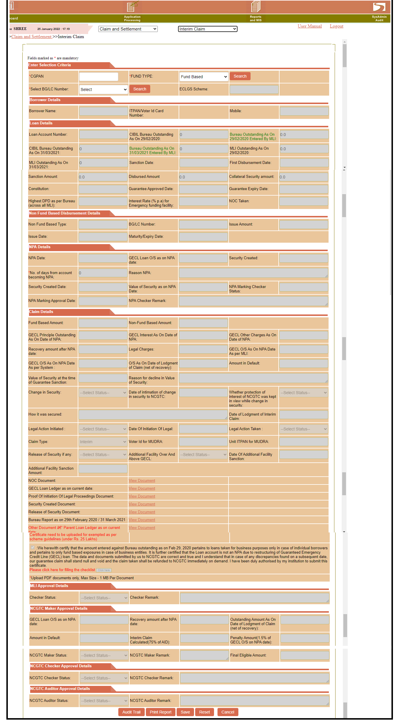

25. Select **Credit Bureau Name**

26. Enter **Reference Number of Borrower**

27. Enter **Parent Loan Account Number**

28. Documents to be uploaded -

1. **NOC document** is mandatory if NOC is taken.
2. **GECL Loan Ledger as on Current date** document is mandatory.
3. **Proof of Initiation of Legal Proceeding document** is mandatory if legal action taken.
4. **Security Document** if security is **Yes**
5. **Release of Security Document** if Release of Security is **Yes**
6. **Bureau Report as on 29th February 2020 / 31st March 2021** is mandatory
7. **Other Document Parent Loan Ledger as on current date** :

**Certificates need to be uploaded for exempted as per scheme guidelines (under Rs 25 lakhs) :** is mandatory

1. **GECL sanction letter for cases above 25 lakhs (outstanding loan on the reference date plus loan sanctioned under GECL) :** Is mandatory if the highest MLI O/S and Sanction Amount is greater than 25 lakh

29. Select checklist details under **Click Here**.

30. Click on ‘Print Report’ button to check entered details.

31. Click on ‘**Save**’ button - the data flows to MLI Checker level

**Interim Claim – MLI Checker level**

1. Login with ‘**MLI Checker**’

2. Select **Claim and Settlement**🡪 **Interim Claim**

3**.** Enter CGPAN and Select Fund Type

4. If CGPAN is Non Fund Type then select ‘**BG/LC Number**’

5. Enter Approval Details ('Approve' and 'Return' values would be provided, if MLI Checker select Return then it should go to MLI Maker)

6. Click on ‘**Save**’ button - the data flows to NCGTC Maker level



**Interim Claim – NCGTC Maker level**

1. Login with ‘**NCGTC Maker’**

2. Select **Claim and Settlement** 🡪 **Interim Claim**

3**.** Enter CGPAN and Select Fund Type

4. If CGPAN is Non Fund Type then select ‘**BG/LC Number**’

5. Enter approval details ('NCGTC Maker will have only one option as “Send for Approval / Rejection” with Mandatory Remarks field.)

6. Click on ‘**Save**’ button - the data flows to NCGTC checker level

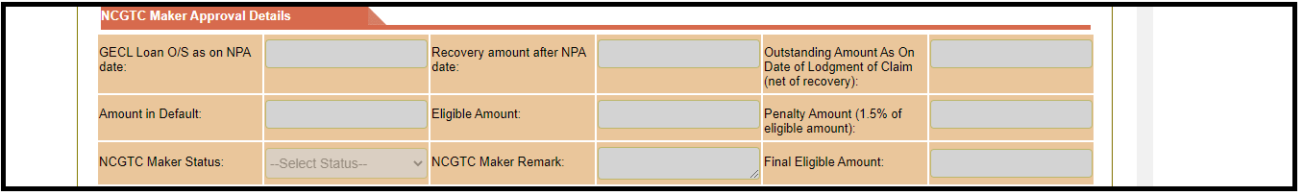

**Interim Claim – NCGTC Checker level**

1. Login with ‘**NCGTC Checker**’

2. Select **Claim and Settlement** 🡪 **Interim Claim**

3**.** Enter CGPAN and Select Fund Type

4. If CGPAN is Non Fund Type then select ‘**BG/LC Number**’

5. Enter approval details ('Approve' and 'Return' values would be provided, if NCGTC Checker select Return then it should go to MLI Maker)

6. Click on ‘**Save**’ button - the data flows to NCGTC Auditor level



**Interim Claim – NCGTC Auditor level**

1. Login with ‘**NCGTC Auditor**’

2. Select **Claim and Settlement** 🡪 **Interim Claim**

3**.** Enter CGPAN and Select Fund Type

4. If CGPAN is Non Fund Type then select ‘**BG/LC Number**’

5. Enter approval details ('Approve' and 'Return' values would be provided, if NCGTC Auditor select Return then it should go to NCGTC Maker)

6. Click on ‘**Save**’ button - the data flows to NCGTC Accountant for payment



**Final Claim – MLI Maker level**

**Menu:** **Go to Application Processing🡪** **Claim and Settlement**🡪 **Final Claim**

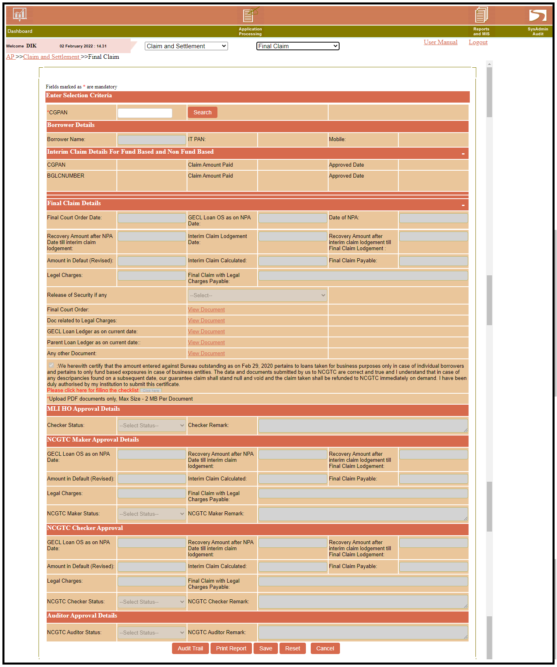

1. Enter **CGPAN** and click on **Search.**

2. Enter **Final Court Order Date**

3. Enter **Legal charges**

4. Enter **Recovery Amount after Interim Claim Lodgement till Final Claim Lodgement**

5. Select Yes/No option from **Release of Security if Any**

6. Documents to be uploaded -

1. **Final Court Order** document is mandatory.
2. **Doc Related to Legal Charges** document is mandatory.
3. **GECL Loan Ledger as on current date** document is mandatory.
4. **Parent Loan Ledger as on current date** document is mandatory
5. **Release of Security Document** if Release of Security is **Yes**
6. **Any Other Document**

7. Select checklist details under **Click Here**.

8. Click on ‘Print Report’ button to check entered details.

9. Click on ‘**Save**’ button - the data flows to MLI Checker level

**Final Claim – MLI Checker level**

1. Login with ‘**MLI Checker**’

2. Go to **Claim and Settlement**🡪 **Final Claim**

3**.** Enter CGPAN and Select Fund Type

4. If CGPAN is Non Fund Type then select ‘**BG/LC Number**’

5. Enter Approval Details ('Approve' and 'Return' values would be provided, if MLI Checker select Return then it should go to MLI Maker)

6. Click on ‘**Save**’ button - the data flows to NCGTC Maker level



**Final Claim – NCGTC Maker level**

1. Login with ‘**NCGTC Maker’**

2. Select **Claim and Settlement** 🡪 **Final Claim**

3**.** Enter CGPAN and Select Fund Type

4. If CGPAN is Non Fund Type then select ‘**BG/LC Number**’

5. Enter approval details ('NCGTC Maker will have only one option as “Send for Approval / Rejection” with Mandatory Remarks field.)

6. Click on ‘**Save**’ button - the data flows to NCGTC checker level

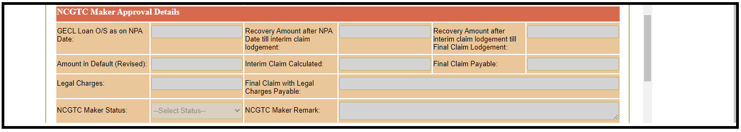

**Final Claim – NCGTC Checker level**

1. Login with ‘**NCGTC Checker**’

2. Select **Claim and Settlement** 🡪 **Final Claim**

3**.** Enter CGPAN and Select Fund Type

4. If CGPAN is Non Fund Type then select ‘**BG/LC Number**’

5. Enter approval details ('Approve' and 'Return' values would be provided, if NCGTC Checker select Return then it should go to MLI Maker)

6. Click on ‘**Save**’ button - the data flows to NCGTC Auditor level

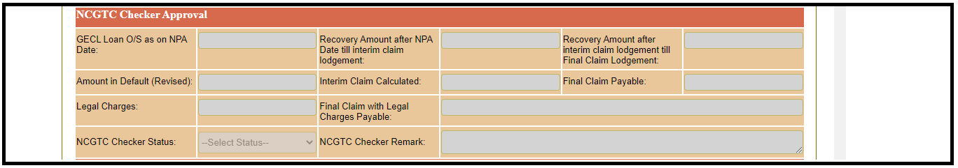

**Final Claim – NCGTC Auditor level**

1. Login with ‘**NCGTC Auditor**’

2. Select **Claim and Settlement** 🡪 **Final Claim**

3**.** Enter CGPAN and Select Fund Type

4. If CGPAN is Non Fund Type then select ‘**BG/LC Number**’

5. Enter approval details ('Approve' and 'Return' values would be provided, if NCGTC Auditor select Return then it should go to NCGTC Maker)

6. Click on ‘**Save**’ button - the data flows to NCGTC Accountant for payment



**Bureau Bulk Upload**

**Menu : Application Processing🡪 Claim and settlement🡪 Bureau Bulk Upload**

**Bureau Bulk Upload template provided on site in Undertaking folder**

**While uploading data by Maker ID, Checker Status and Remark should be blank.**

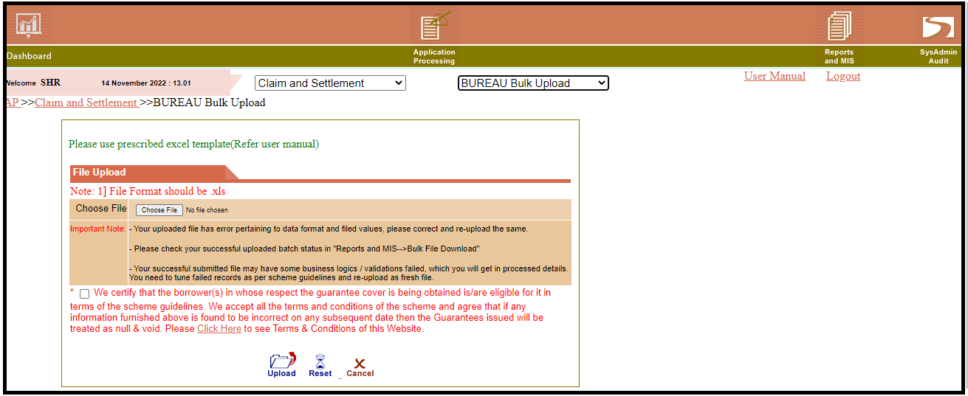

**1. For Bureau Maker bulk file status, Go to Report and MIS-->Bulk File Download**

**Select Bureau Maker Bulk File Status from 'Categories' dropdown.**

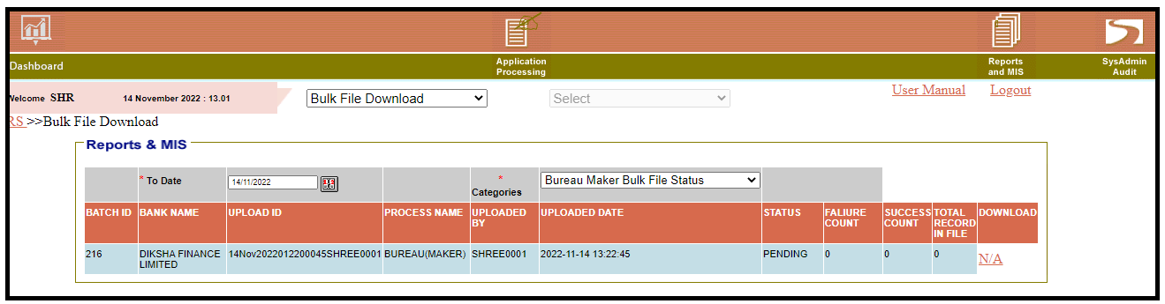

**2. For Bureau Checker bulk file status, Go to Report and MIS-->Bulk File Download**

**Select Bureau Checker Bulk File Status from 'Categories' dropdown**

**3. For Bureau pending for Checker approval status, Go to Report and MIS-->Bulk File Download**

**Select Bureau Pending for Checker Approval from 'Categories' dropdown.**

**Closure Entry -**

**Menu : Application Lodgement🡪 Closure Entry**

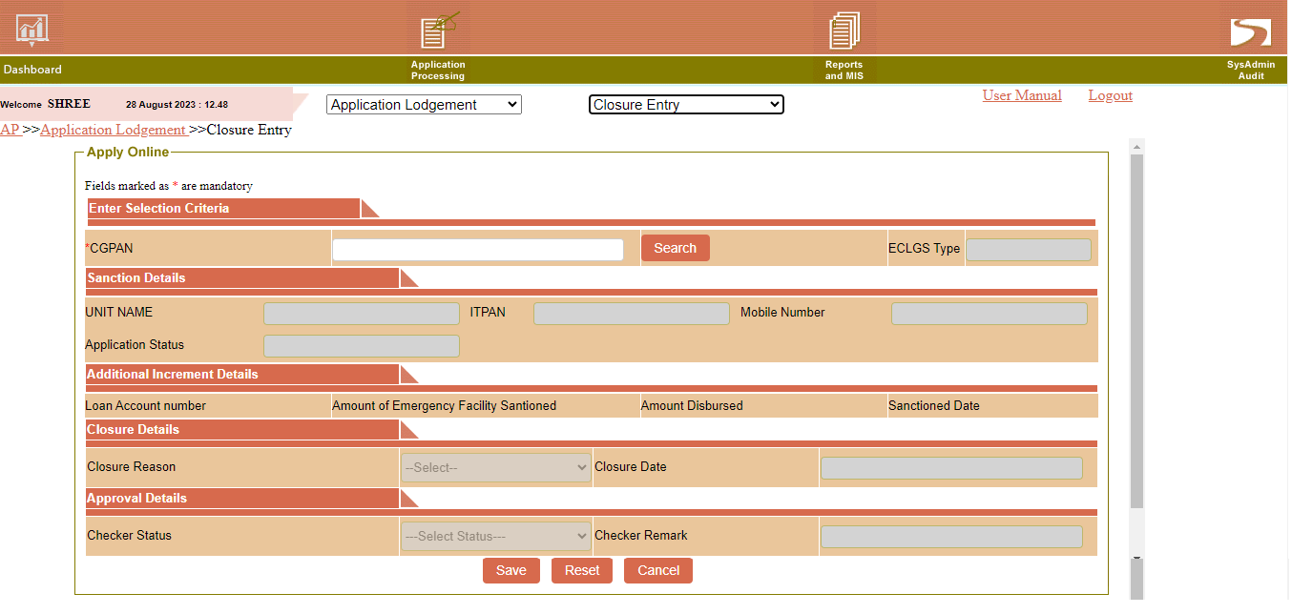

1. Login with **MLI Maker.**

2. Enter **CGPAN** and click on **Search.**

3. Select Closure Reason **Pre-Close** or **Normal Close**

4. Select Closure Date

5. Click on ‘**Save**’ button - the data flows to MLI Checker level

**MLI Checker Level -MLI Checker level**

1. Login with **MLI Checker.**

2. Go to **Application Lodgement**🡪 **Closure Entry**

3. Enter **CGPAN** and click on **Search.**

4.Enter Approval Details ('Approve' and 'Return' values would be provided, if MLI Checker select Return then it should go to MLI Maker)

5. Click on ‘**Save**’ button

**Update Mudra ITPAN Bulk Upload**

**Menu : Application Processing🡪 Application Lodgement🡪 Update Mudra ITPAN Bureau Bulk Upload**

**Update Mudra ITPAN Bureau Bulk Upload template provided on site in Undertaking folder**

**While uploading data by Maker ID, Checker Status and Remark should be blank.**

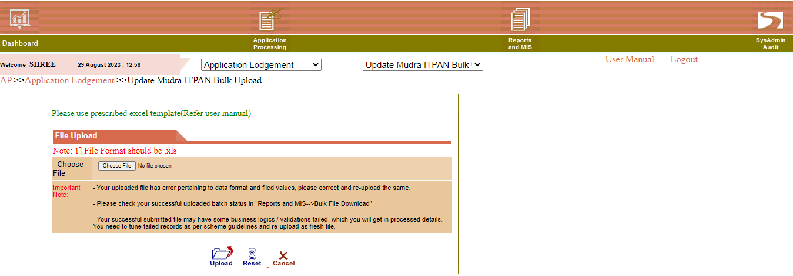

**1. For Bureau Maker bulk file status, Go to Report and MIS-->Bulk File Download**

**Select Mudra ITPAN Maker Bulk File Status from 'Categories' dropdown.**

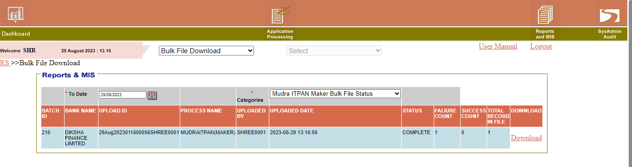

**2. For Mudra ITPAN Checker bulk file status, Go to Report and MIS-->Bulk File Download**

**Select Mudra ITPAN Checker Bulk File Status from 'Categories' dropdown**

**3. For Mudra ITPAN pending for Checker approval status, Go to Report and MIS-->Bulk File Download**

**Select Mudra ITPAN Pending for Checker Approval from 'Categories' dropdown.**

IT Email Address: [itsupport@ncgtc.in](mailto:itsupport@ncgtc.in)

Phone No. 0253 6636 594